**UMUC HeadPhone Test Plan**

Files: HeadPhone.java, Test HeadPhone.java

Author: John Bernat

Date: 04Dec2016

**Description:**

This program creates HeadPhone class and assigns various attributes to objects. The test cases assign various values as parameters when creating objects and adjusts some of the values and retrieves them for output.

**Test Case 1: headPhoneOne**

|  |  |  |  |  |
| --- | --- | --- | --- | --- |
| Parameter | Input | Expected Output | Actual Output | Pass/Fail |
| volume | None (default) | 2 | 2 | Pass |
| pluggedIn | None (default) | False | False | Pass |
| Manufacturer | None (default) | unknown | 0.0 | Pass |
| headPhoneColor | None (default) | java.awt.Color[r=0,g=0,b=0] | java.awt.Color[r=0,g=0,b=0] | Pass |
| toString | None (default) | (volume=1, pluggedIn=false, manufacturer= unknown, headPhoneColor=  java.awt.Color[r=0,g=0,b=0]) | (volume=1, pluggedIn=false, manufacturer= unknown, headPhoneColor=  java.awt.Color[r=0,g=0,b=0]) | Pass |
| setVolume | 1 | 1 | 1 | Pass |
| setPluggedIn | false | false | false | Pass |
| setManufacturer | Skull Candy | Skull Candy | Skull Candy | Pass |
| setHeadPhoneColor | Color.gray | java.awt.Color  [r=128,g=128,b=128] | java.awt.Color  [r=128,g=128,b=128] | Pass |
| changeVolume | 3 | 3 | 3 | Pass |

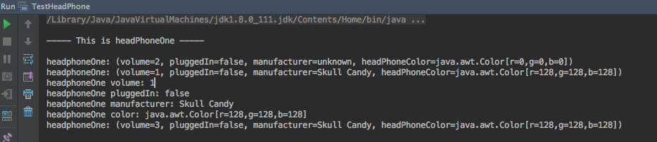

**Test Case 2: headPhoneTwo**

|  |  |  |  |  |
| --- | --- | --- | --- | --- |
| Parameter | Input | Expected Output | Actual Output | Pass/Fail |
| volume | 1 | 1 | 1 | Pass |
| pluggedIn | true | true | true | Pass |
| Manufacturer | sony | sony | sony | Pass |
| headPhoneColor | Color.blue | java.awt.Color[r=0,g=0,b=255] | java.awt.Color[r=0,g=0,b=255] | Pass |
| toString | None (default) | (volume=1,  pluggedIn=true,  manufacturer=sony, headPhoneColor=  java.awt.Color[r=0,g=0,b=255]) | (volume=1,  pluggedIn=true,  manufacturer=sony, headPhoneColor=  java.awt.Color[r=0,g=0,b=255] | Pass |
| setVolume | 3 | 3 | 3 | Pass |
| setPluggedIn | false | false | false | Pass |
| setManufacturer | Sony | Sony | Sony | Pass |
| setHeadPhoneColor | Color.cyan | java.awt.Color  [r=0,g=255,b=255] | java.awt.Color  [r=0,g=255,b=255] | Pass |
| changeVolume | 2 | 2 | 2 | Pass |

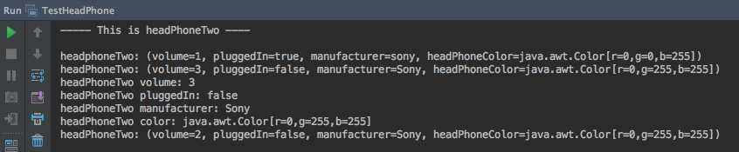

**Test Case 3: headphoneThree**

|  |  |  |  |  |
| --- | --- | --- | --- | --- |
| Parameter | Input | Expected Output | Actual Output | Pass/Fail |
| volume | 3 | 3 | 3 | Pass |
| pluggedIn | false | false | false | Pass |
| Manufacturer | Beats | Beats | Beats | Pass |
| headPhoneColor | Color.green | java.awt.Color[r=0,g=255,b=0] | java.awt.Color[r=0,g=255,b=0] | Pass |
| toString | None (default) | (volume=3,  pluggedIn=false, manufacturer=Beats, headPhoneColor=  java.awt.Color[r=0,g=255,b=0]) | (volume=3,  pluggedIn=false, manufacturer=Beats, headPhoneColor=  java.awt.Color[r=0,g=255,b=0]) | Pass |
| setVolume | 1 | 1 | 1 | Pass |
| setPluggedIn | True | True | true | Pass |
| setManufacturer | Beats By Dre | Beats By Dre | Beats By Dre | Pass |
| setHeadPhoneColor | Color.pink | java.awt.Color  [r=255,g=175,b=175] | java.awt.Color  [r=255,g=175,b=175] | Pass |
| changeVolume | 2 | 2 | 2 | Pass |

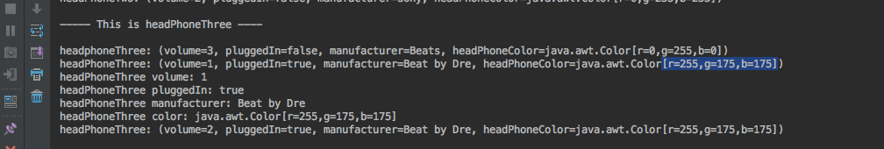

**Test Case 4: HeadphoneFour**

|  |  |  |  |  |
| --- | --- | --- | --- | --- |
| Parameter | Input | Expected Output | Actual Output | Pass/Fail |
| volume | 3 | 3 | error | fail |
| pluggedIn | off | off | error | fail |
| Manufacturer | samsung | samsung | error | fail |
| headPhoneColor | Color.tan | ? | error | fail |
| toString | None (default) | ? | error | fail |
| setVolume | 1 | 1 | error | fail |
| setPluggedIn | On | on | error | fail |
| setManufacturer | Samsung | Samsung | error | fail |
| setHeadPhoneColor | Color.gray | java.awt.Color  [r=128,g=128,b=128] | Error | fail |
| changeVolume | Louder | ? | error | fail |

